**Spike:** 12

**Title:** Performance Measurement and Optimisations

**Author:** Ryan Chessum, 102564760

**Goals / deliverables:**

* Code, see \24 - Spike - Profiling, Performance and Optimsation\Task 24\
* Spike Report

**Technologies, Tools, and Resources used:**

List of information needed by someone trying to reproduce this work

* Visual Studio 2019
* C plus plus reference (<https://www.cplusplus.com/reference/>)
* SDL2
* Cpp file from canvas

**Tasks undertaken:**

* Download and install Visual Studio
* Create a new C++ project
* Download SDL2 Development libraries
* Link libraries to project
* Download the cpp file from canvas and put it in the project
* Run the tests and record data.
* Analyse data using a graph
* Make optimisations based on results

**What we found out:**

On canvas there is a file that runs SDL performance tests with rects and collision detection.

From the results function D is clearly the best so that is the function I am going to use. Now to add some improvements.

First, I changed the render function to use a reference rather than copying the box. Though this wont show in the results as the renderer is turned off.

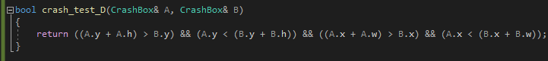

I changed the return using an && comparison. This is very small but it means that if there is a collision it wont have to go through to another return or through multiple if statements.

The CONTACT_NO is now set in the other for loop meaning that the program doesn’t have to loop through the array twice.

It also now uses else if logic, so if wrap around is detected it skips over the opposite screen edge.

If we now compare the improved function to the old one we can see the difference. The improvements now let the program make over 9000 loops per second much more consistently .

